Query Object
Design Document
Contents
Overview 1
Custom Formula 1
Parameterized Query 2
Class diagram 3
API Summary 4

Overview
The query-object (IQuery) provides the interfaces used to represent a user-defined query. The query consists of constraints (represented by IConstraints). User defined conditions (e.g. Participant.sex = ‘female’) are represented by ICondition. Conditions on different attributes of an entity are grouped together as a rule (represented by IRule). Various rules/expressions on an entity can be logically grouped into an expression (represented by IExpression). An expression thus consists of operands (i.e. rules or sub-expressions; this is represented by IExpressionOperand) connected by logical operators (AND, OR). Operands in an expression can also be parenthesized.
The various expressions thus formed need to be linked together. Two expressions are linked by an association (represented by IAssociation). These linkages among the expressions constitute the join graph (represented by IJoinGraph).
An expression can be marked as “in view”; this means that the entity corresponding to that expression will be included in the output of the query. Thus, all expressions that are “in view” constitute the output of the query.

Custom Formula
In addition to the constraints based on simple rules, the user can create arbitrarily complex constraints involving multiple attributes from various classes. Such a constraint is called a custom formula (represented by ICustomFormula). An example of a custom formula is
FixedEventParameters.timestamp – CollectedEventParameters.timestamp <= 30 minutes
The relational operator (<=) separates the custom formula into two parts: a left-hand side (LHS) and a right-hand side (RHS). Each side is referred to as a term (represented by ITerm).
A term can have literals (e.g. 30 minutes), and attributes (e.g. FixedEventParameters.timestamp) sourced from existing expressions. Thus, in order to create the LHS term above, two expressions, on FixedEventParameters and CollectedEventParameters, should exist.
As the above example illustrates, a term contains arithmetic operands (represented by IArithmeticOperand); these operands are connected by binary arithmetic operators (+, -, *, /). An arithmetic operand can either be a literal (represented by ILiteral) or an attribute sourced from an expression (represented by IExpressionAttribute). The arithmetic operands in a term can also be parenthesized.
A custom formula, like a rule or sub-expression, is used an as operand in an expression.

Parameterized Query
The user/admin may define a query which has some conditions as parameters. Such a condition is called a parameterized condition (represented by IParameterizedCondition). The value in a parameterized condition is specified just before the query is executed. A query that has one or more parameterized conditions is called a parameterized query (represented by IParameterizedQuery).

Class diagram
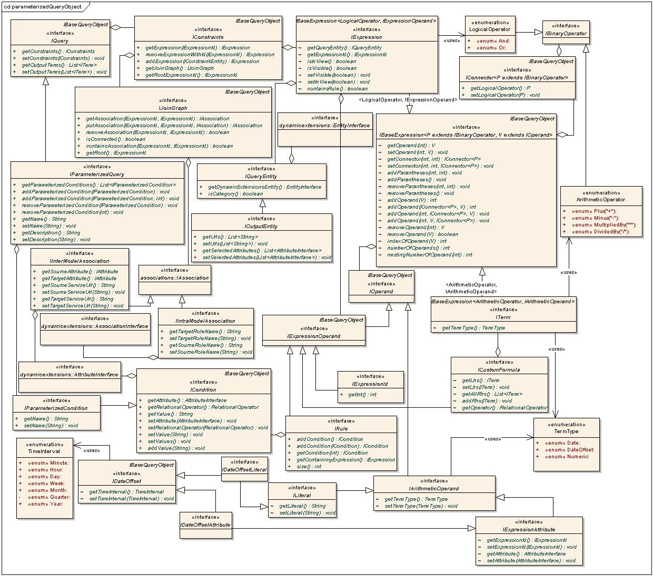
Interfaces that compose the query-object

Note: The text on the generalization links refers to type parameters.

API Summary
ICondition | A condition containing an attribute, relational operator and value(s). E.g. participant.sex = 'Male'
RelationalOperator | An enumeration of the relational operators (=, <, >, Between, In etc.)
IRule | A list of conditions, on different attributes of an Entity.  Note: The conditions in a rule are implicitly linked by AND condition.
IQueryEntity | An entity that is associated with an expression.
IConstraints | Contains information about the constraints of a query. It contains a list of IExpression’s that is indexed by IExpressionId. This is global storage location for all expressions in a query. Only calling the addExpression() method here can create an IExpression. It also contains a join graph for specifying how the expressions are linked together.
IBaseExpression | A list of operands and the operators connecting them together form a base-expression. The operators are identified by the position of the operands on either side. The operator and operand types are parameterized.
IOperand | Represents an operand in an IBaseExpression.
IBinaryOperator | Represents the binary operator in an IBaseExpression.
IConnector | Represents a connector between two operands in an IBaseExpression. The nesting represents the number of parentheses (depth of parentheses) around the operator portion (e.g. AND, OR) of the connector. The operator type is parameterized.
IExpression | An IExpression is an IBaseExpression with operand of type IExpressionOperand and operator of type LogicalOperator.  An IExpression belongs to a constraint entity and constraints on another associated entity will be present as a sub expression on the associated entity. Conversely, if an expression has a sub-expression, there must an association in the join graph from the parent expression to the sub expression.  Note: "sub-expression" refers to an operand that is the IExpressionId of the child expression. The entity of the sub-expression will generally be different from the entity of this expression (exception is when a class is associated to itself, e.g. Specimen). The expression for an ExpressionId is found from IConstraints.
IExpressionId | An immutable wrapper around int used to uniquely identify an expression within a query. It is auto generated when an expression is added to a query.
IExpressionOperand | A marker interface for an operand. An operand is either a sub expression (in which case, the corresponding expression id is added), or a rule.
LogicalOperator | An enumeration of the operators AND, OR.
IJoinGraph | A rooted, directed acyclic graph with expressions as vertices, and associations as edges. The graph will always contain all the expressions' ids (obtained from IConstraints) as vertices. The vertices will be added to/removed from the IJoingraph as and when expressions are added to/removed from IConstraints. The methods in IJoingraph can only add/remove associations among the vertices.  If v1 and v2 are two vertices, the direction will be v1->v2 if v2 is a sub expression of v1. The user of the API will generally build the join graph based on metadata, and in cases of ambiguity, the user will help forming this graph. This graph basically determines the join conditions in the query. E.g. for each edge (v1, v2) between two vertices v1 and v2, there will be a join between the functional classes of the expressions denoted by v1 and v2; and the join condition is determined by the info in the IAssociation.
IQuery | The query object. This is the final unit that is built from UI and persisted.
ITerm | An ITerm is an IBaseExpression with operand of type IArithmeticOperand and operator of type ArithmeticOperator. The type of a term can be obtained by calling getTermType (); the term-type (represented by TermType) is computed based on the term-types of the operands and operators in the term.
ArithmeticOperator | An enumeration of the arithmetic operators (+, - etc.)
IArithmeticOperand | Represents an operand in a term. Each operand has a term-type associated with it.
TermType | An enumeration of the types of terms (currently Date, Numeric, DateOffset).
ICustomFormula | Represents a custom formula as an LHS term and a list of RHS terms (relational operators such as Between, In have more than one RHS).
ILiteral | Represents a literal in a term.
IExpressionAttribute | Represents an attribute in a term.
IDateOffset | Contains a time interval for an operand that is to be used to offset a date.
ITimeIntervalEnum | Marker interface for the time interval enumeration classes (DSInterval and YMInterval).
DSInterval | An enumeration of the time intervals Minute, Hour, Day, Week
YMInterval | An enumeration of the time intervals Month, Quarter, Year
IDateOffsetLiteral | Represents a literal that is used to offset a date.
IDateOffsetAttribute | Represents an attribute that is used to offset a date.
IParameterizedCondition | Represents a parameterized condition.
IParameterizedQuery | Represents a query that contains one or more parameterized conditions.
QueryObjectFactory | Factory to create instances of the above interfaces.

